

AMERICAN INTERNATIONAL UNIVERSITY–BANGLADESH (AIUB)
FACULTY OF SCIENCE & TECHNOLOGY

ELECTRONIC DEVICES LAB
Section: Y (GROUP-1) LAB REPORT ON:

Determination of Characteristic Curve of a Diode.
Submitted to: LIA MONI

Submitted By:

Serial no | Name | ID
1 | Safiha Ayman | 23-51609-2
2 | Syed Raiyan Emon | 24-57810-2
3 | Sayeda Tanjila Ahmed (Apurba) | 24-56599-1
4 | Farhana Zaman | 23-51559-2
5 | Shahriar Amin | 24-57282-2

Title of Experiment: Determination of Characteristic Curve of a Diode Abstract:
The forward-bias characteristic curve of a silicon diode was determined by measuring the diode voltage and current for different applied voltages. The experiment was performed both practically using hardware components and through simulation using NI Multisim. From the obtained V–I characteristics, the knee voltage as well as static and dynamic resistances were calculated. A comparison between experimental and simulated results was conducted, showing close agreement. The experiment successfully demonstrated the operating behavior of a semiconductor diode and validated theoretical expectations.

Theory:
A semiconductor diode is formed by joining p-type and n-type materials, creating a pn junction within a single silicon crystal. Due to diffusion of charge carriers, a depletion region is formed at the junction.
In forward bias, the applied voltage reduces the depletion region, allowing current to flow after exceeding the cut-in voltage (approximately 0.6–0.7 V for silicon). In reverse bias, the depletion region widens, and only a small leakage current flows.
The electrical behavior of the diode is represented by its V–I characteristic curve, which is used to determine important parameters such as knee voltage, static resistance, and dynamic resistance.

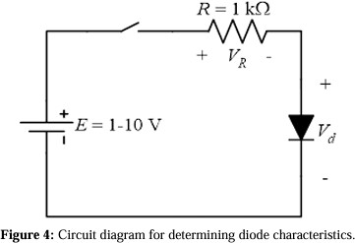

Methodology:
The experiment was conducted using both simulation and hardware implementation.
First, the circuit was designed and simulated using NI Multisim according to the given circuit diagram. A DC voltage source was applied and varied from 0 V to 12 V, and the corresponding diode voltage and current were observed.
Then, the circuit was implemented on a breadboard using a diode, resistor (1 kΩ), DC power supply, and multimeter. The voltage gradually increased, and readings were recorded.

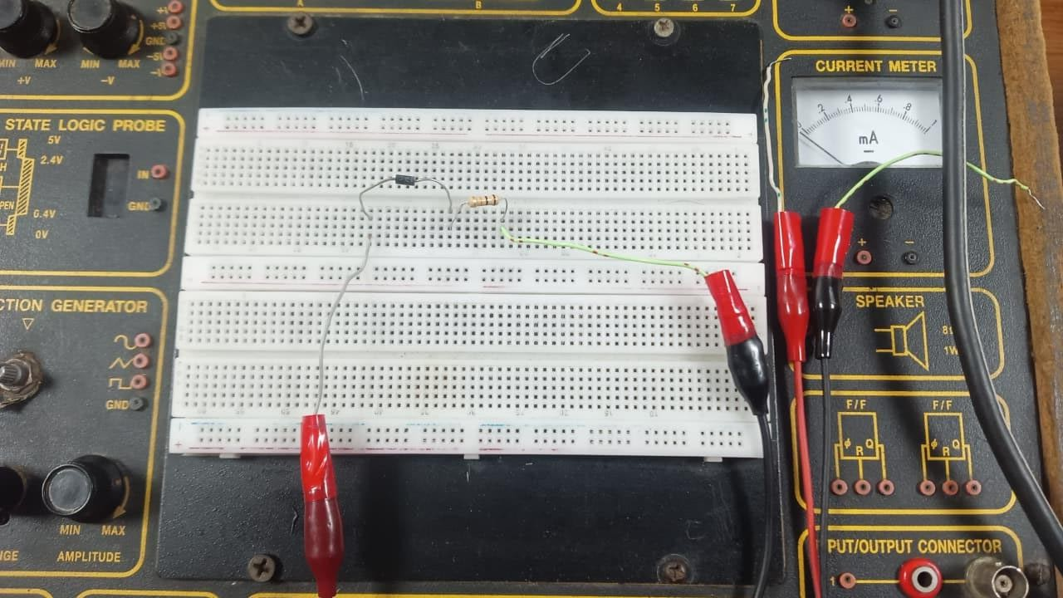
Hardware Diagram - 1

Results and Analysis:
The V–I characteristic curve showed that current remains nearly zero until approximately 0.5–0.6 V, after which it increased rapidly.

Source Voltage, Es  (V) | Diode Voltage, VD (V) | Resistor Voltage, VR  (V) | Diode Current, Id (mA)
0 | -0.02 | 0 | 0
0.1 | 0.14 | 0 | 0
0.2 | 0.38 | 0.03 | 0
0.3 | 0.40 | 0.06 | 0
0.4 | 0.44 | 0.13 | 0.01
0.5 | 0.46 | 0.21 | 0.01
0.6 | 0.47 | 0.33 | 0.02
0.7 | 0.48 | 0.42 | 0.03
0.8 | 0.48 | 0.38 | 0.04
0.9 | 0.49 | 0.47 | 0.05
1.0 | 0.50 | 0.56 | 0.06
2.0 | 0.54 | 1.50 | 0.15
3.0 | 0.56 | 2.49 | 0.26
4.0 | 0.57 | 3.48 | 0.35
5.0 | 0.58 | 4.47 | 0.46
6.0 | 0.59 | 5.49 | 0.56
7.0 | 0.60 | 6.48 | 0.65
8.0 | 0.61 | 7.44 | 0.75
9.0 | 0.61 | 8.47 | 0.86
10.0 | 0.62 | 9.47 | 0.96
11.0 | 0.62 | 10.43 | 1.05
12.0 | 0.63 | 11.42 | 1.16

Table 1 Data for the VD - Id Curve

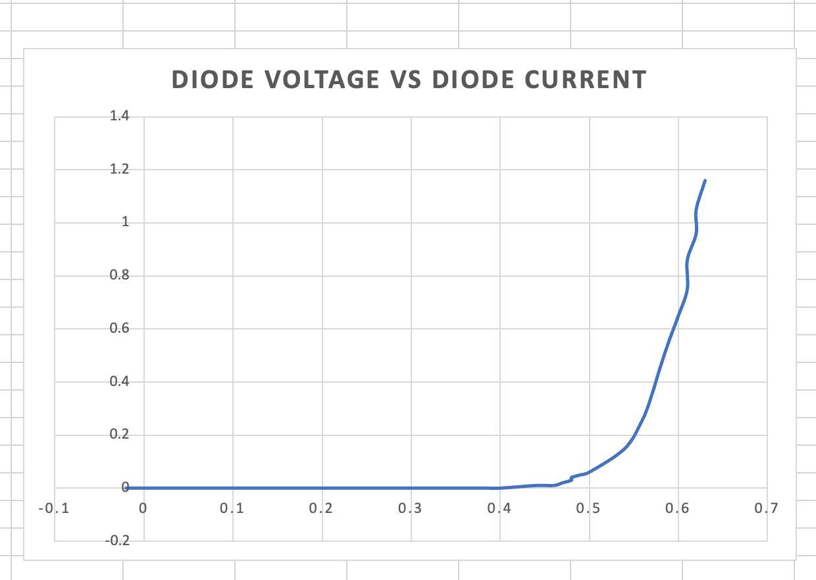
Graph - 1: Diode IV Characteristics

Simulation Diagrams:
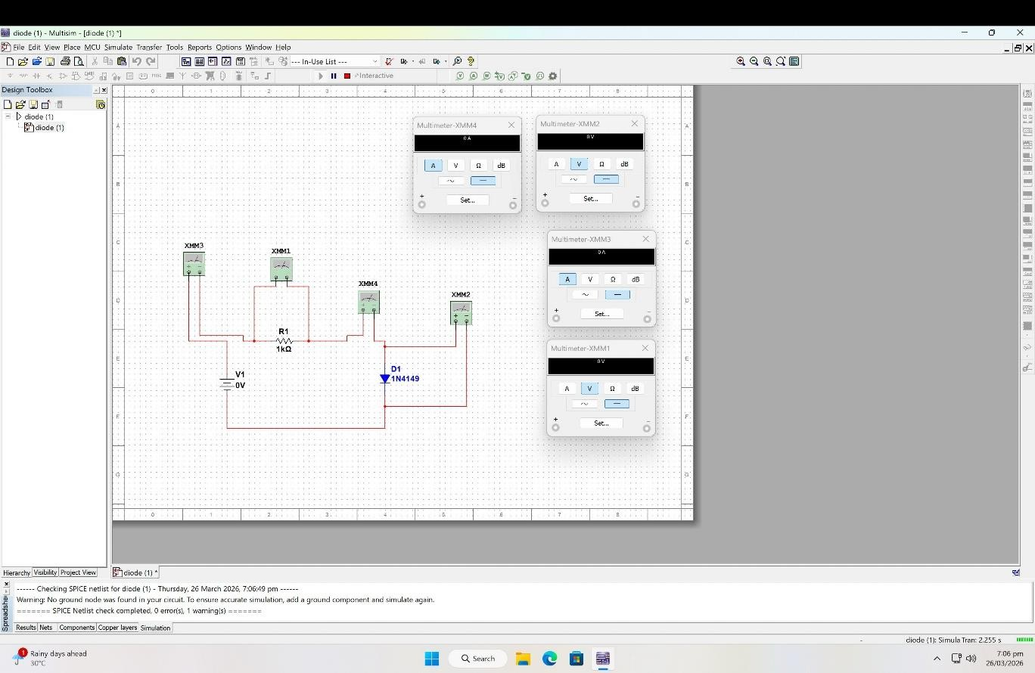
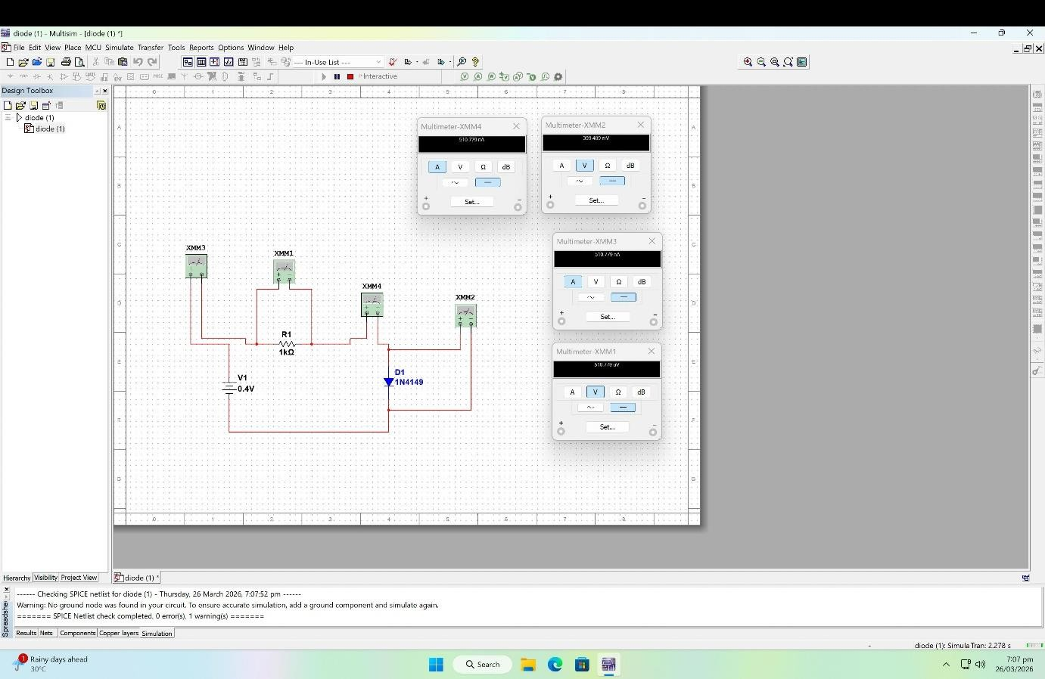
Simulation Diagram - 1

Simulation Diagram - 2

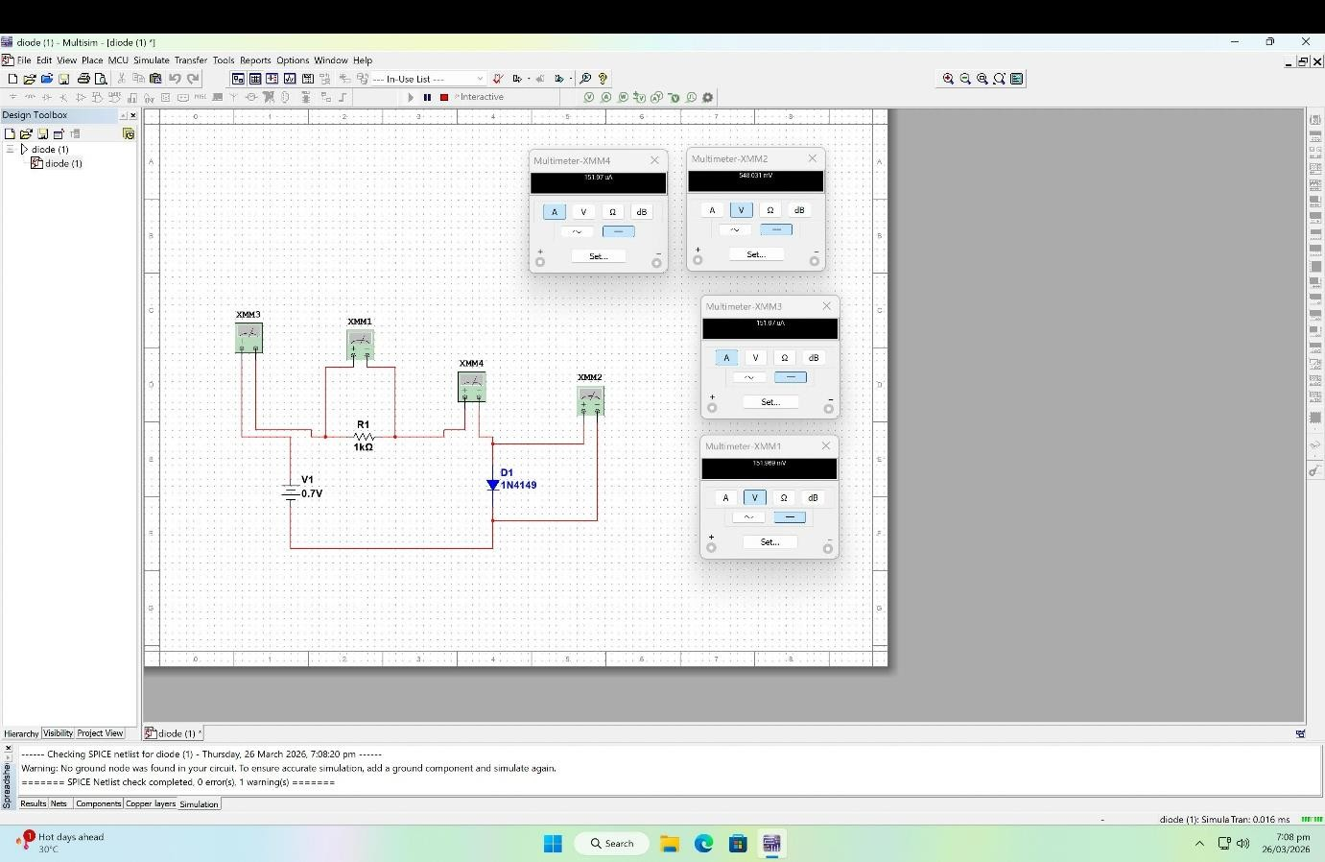
Simulation Diagram - 3

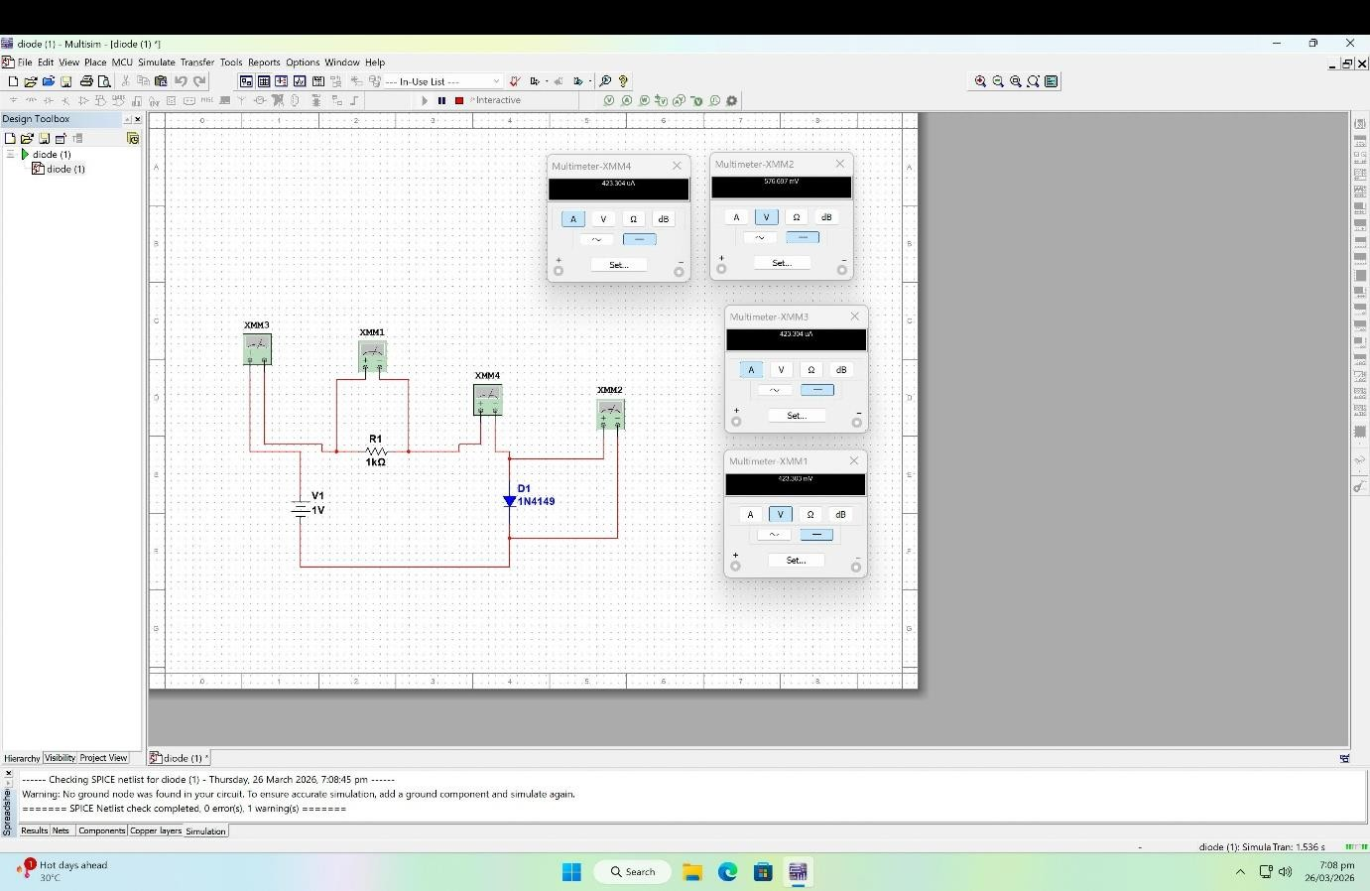
Simulation Diagram - 4

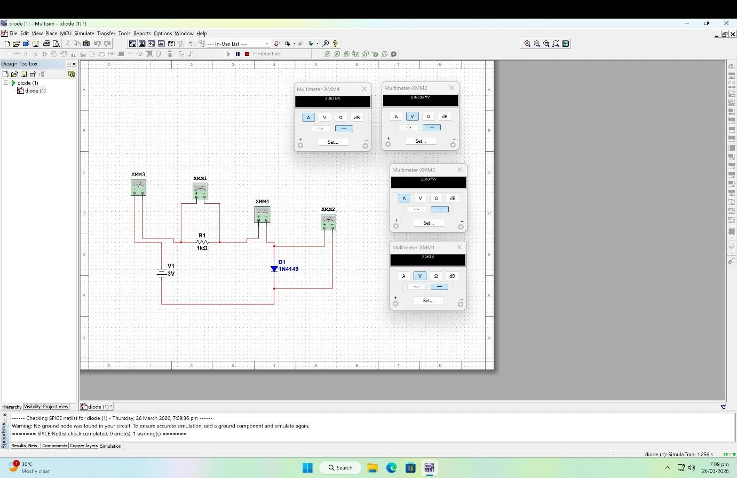
Simulation Diagram - 5

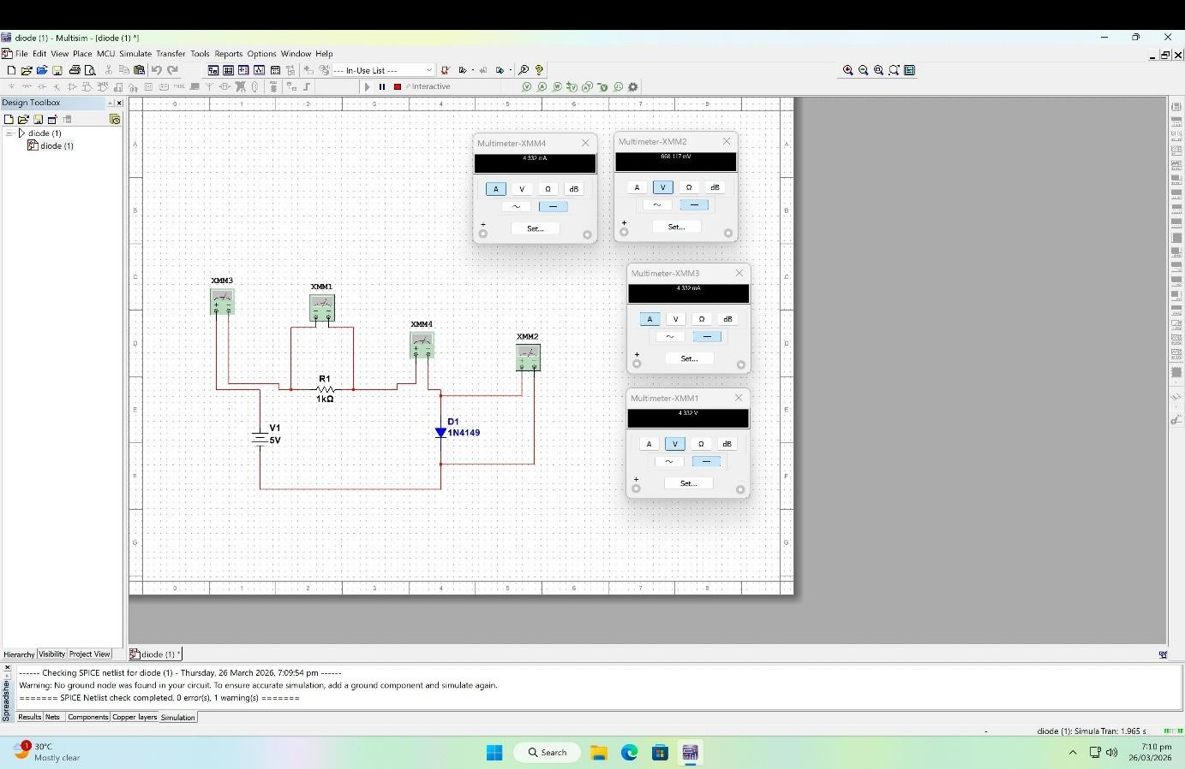
Simulation Diagram - 6

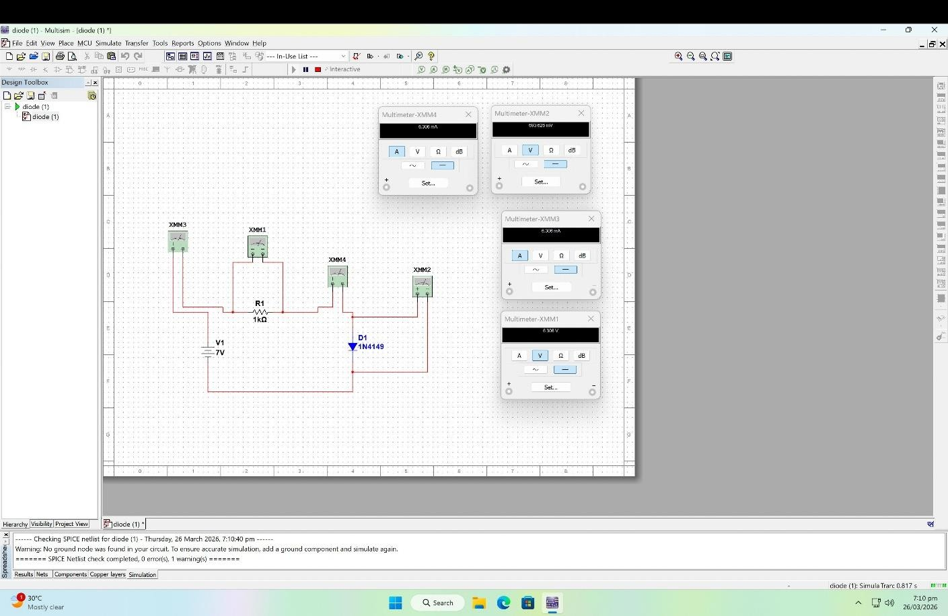
Simulation Diagram - 7
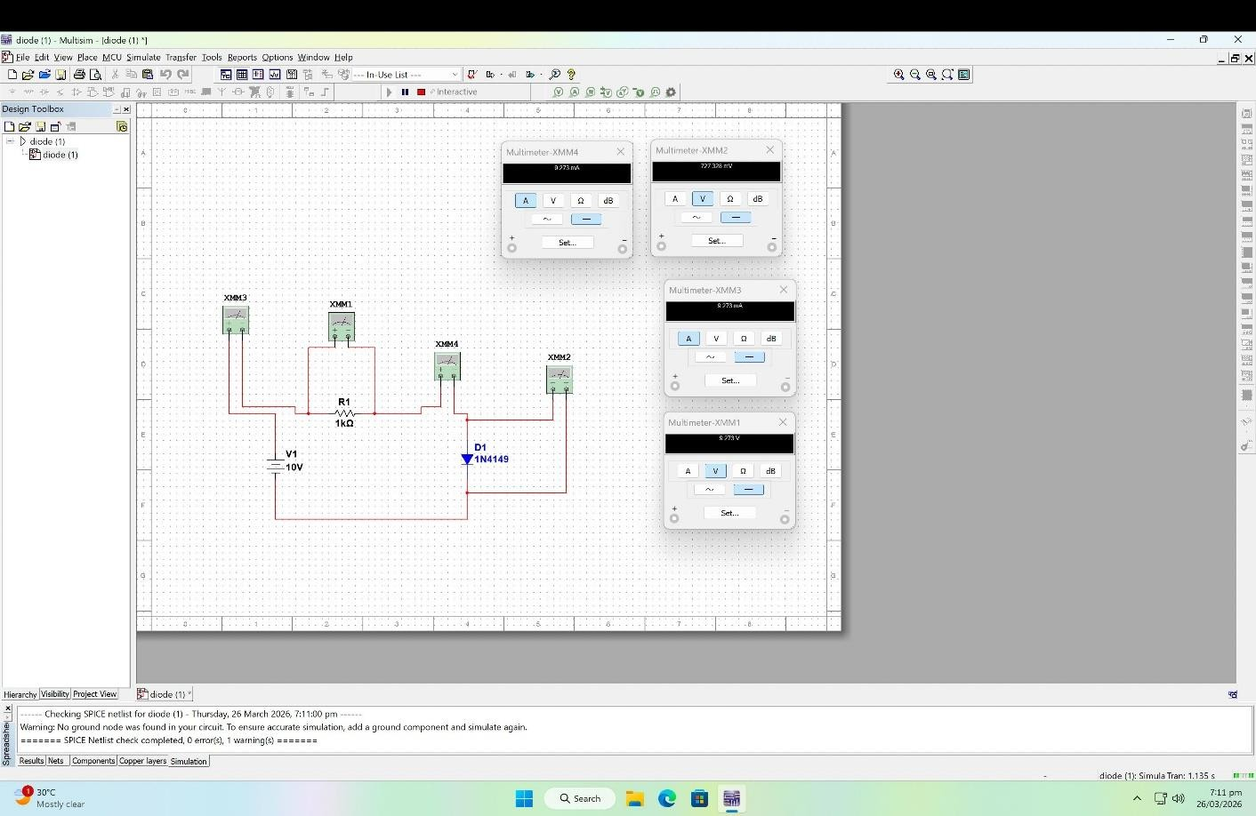
Simulation Diagram - 8

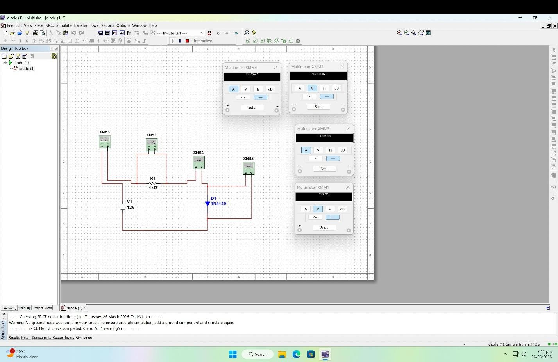
Simulation Diagram - 9

Source Voltage, Es  (V) | Diode Voltage, VD (V) | Resistor Voltage, VR  (V) | Diode Current, Id (A)
0 | 0 | 0 | 0
0.1 | 0.14 | 0.0 | 0.0
0.2 | 0.38 | 0.03 | 0.01
0.3 | 0.40 | 0.06 | 0.02
0.4 | 0.39 | 0.51 | 0.05
0.5 | 0.46 | 0.21 | 0.08
0.6 | 0.47 | 0.33 | 0.12
0.7 | 0.54 | 0.15 | 0.15
0.8 | 0.55 | 0.25 | 0.20
0.9 | 0.56 | 0.34 | 0.28
1 | 0.57 | 0.42 | 0.42
2 | 0.60 | 1.40 | 0.14
3 | 0.63 | 2.36 | 0.23
4 | 0.65 | 3.35 | 0.33
5 | 0.66 | 4.33 | 0.43
6 | 0.68 | 5.32 | 0.53
7 | 0.69 | 6.30 | 0.63
8 | 0.71 | 7.29 | 0.72
9 | 0.72 | 8.28 | 0.82
10 | 0.72 | 9.27 | 0.92
11 | 0.74 | 10.26 | 1.02
12 | 0.74 | 11.25 | 1.1
Table 2 Data for the VD - Id Curve

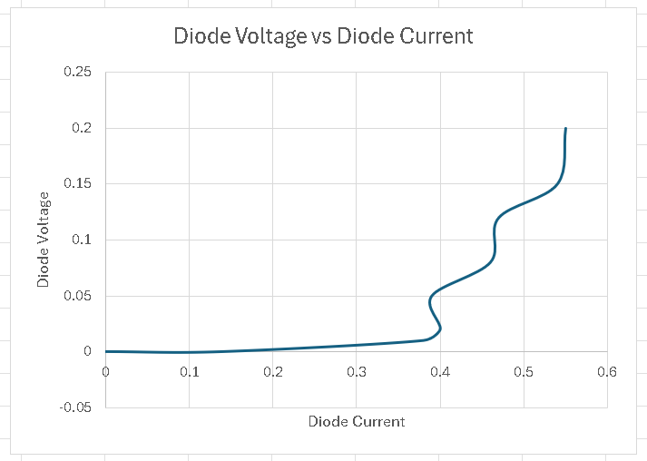
Graph - 1: Diode IV Characteristics

Discussions:
In this experiment, the forward-bias characteristics of a silicon diode were investigated using both hardware implementation and simulation. The V–I characteristic curve was obtained from the measured data, and the behavior of the diode was analyzed.
It was observed that at lower applied voltages, the diode current remained nearly zero. This behavior was expected due to the presence of the depletion region, which prevented current flow. As the applied voltage increased, a point was reached at approximately 0.5–0.6 V where the current began to increase rapidly. This point was identified as the knee voltage of the diode, which is consistent with the theoretical value for a silicon diode.
After the knee voltage, the current was found to increase exponentially with a small increase in voltage, while the diode voltage remained nearly constant. This behavior confirmed the non-linear nature of the diode and matched the expected forward-bias characteristics.
A comparison between the hardware and simulated results were performed. It was found that both sets of results followed a similar trend. However, slight differences were observed between the measured and simulated values. These differences were attributed to several practical factors.

In simulation, ideal components were used, and therefore more accurate and stable values were obtained. In contrast, in the hardware setup, real components were used, which introduced non-ideal effects such as internal resistance, contact resistance in the breadboard, and variations in diode characteristics. Additionally, measurement errors from the multimeter and power supply fluctuations also contributed to the deviations.
It was also observed that the diode voltage increased slowly even after conduction began, which indicated the presence of dynamic resistance. The dynamic resistance was reduced as the current increased, which is consistent with theoretical expectations.
Overall, the experimental results were found to be in good agreement with the theoretical model and simulated results. The behavior of the diode under forward bias was successfully verified through this experiment.

Conclusion:
In this experiment, the V–I characteristics of a silicon diode were successfully determined using both hardware implementation and simulation with NI Multisim. The relationship between diode voltage and current was observed, and the characteristic curve was plotted.
The knee voltage of the diode was identified from the graph, and the expected exponential increase in current after this point was confirmed. The experimental results were found to be in close agreement with the simulated results and theoretical expectations.
Thus, the behavior of the diode under forward bias was successfully verified through this experiment.

Reference:
- Robert L. Boylestad, Louis Nashelsky, Electronic Devices and Circuit Theory, 9th Edition, 2007-2008.
- American International University–Bangladesh (AIUB) Electronic Devices Lab Manual.

